H.T No
Regulations:
A19

Sreenidhi Institute of Science and Technology
(An Autonomous Institution)
Code No:7U110 Date: 24-July-2021 (FN)

M.Tech I-Year I-Semester External Examination, July - 2021 (Regular & Supplementary)
RESEARCH METHODOLOGY AND IPR (DSCE)

Time: 3 Hours Max.Marks:70

Note: a) No additional answer sheets will be provided.
b) All sub-parts of a question must be answered at one place only, otherwise it will not be valued.
c) Missing data can be assumed suitably.

ANSWER ANY 5 OUT OF 8 QUESTIONS. EACH QUESTION CARRIES 14 MARKS.

Bloom's Cognitive Levels of Learning (BCLL)

Remember | L1 | Apply | L3 | Evaluate | L5
Understand | L2 | Analyze | L4 | Create | L6

 |  |  | BCLL | CO(s) | Marks
1. | a) | Compare the type of research with suitable examples. | L5 | CO1 | [7M]
 | b) | Explain the steps in research process with the flow chart. | L2 | CO1 | [7M]
2. | a) | Illustrate the collection of primary data through interview method. | L4 | CO2 | [7M]
 | b) | Apply the Regression analysis for the determination of a statistical relationship between two or more variables. | L3 | CO2 | [7M]
3. | a) | Outline the features of good design in research. | L4 | CO3 | [7M]
 | b) | Explain about the important parametric hypothesis testing. | L2 | CO3 | [7M]
 |  |  | L5
4. | a) | Compute the ANOVA table for the following information relating to three drugs testing to judge the effectiveness in reducing blood pressure for three different groups of people.  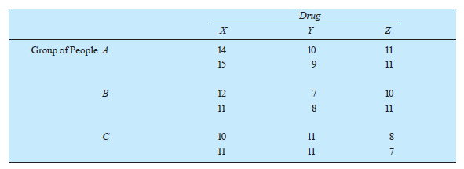 | L3 | CO4 | [7M]
 | b) | Explain the significance of a research report and narrate the various steps involved in writing such a report. | L2 | CO4 | [7M]
5. | a) | Show the patent application process. | L3 | CO5 | [7M]
 | b) | Identify the terms and maintenance of the patent. | L1 | CO5 | [7M]
6. | a) | Illustrate the remedies for infringement. | L1 | CO6 | [7M]
 | b) | Outline the new development in the patent law. | L4 | CO6 | [7M]
7. | a) | List the ethics in research. | L1 | CO1 | [5M]
 | b) | Write the important statistical measures that are used to summarise the research data. | L1 | CO2 | [5M]
 | c) | Discuss the need for research design. | L2 | CO3 | [4M]
8. | a) | Explain the kruskal wallis test using two examples. | L2 | CO4 | [5M]
 | b) | State the post issuances action. | L1 | CO5 | [5M]
 | c) | Outline the infringement. | L4 | CO6 | [4M]

-- 00 -- 00 –

